1. **Data Dive**

**Dataset**: Social Media Users

**Difficulties**:

* **Downloading and Importing**: Ensure the dataset is available in a format (like CSV) that can be easily imported into MySQL Workbench.
* **Schema Understanding**: Understanding the structure of the dataset (columns, data types) to plan queries effectively.

**Interesting Observation**:

* One interesting aspect to explore could be the distribution of users across different social media platforms and their demographics, such as age or gender.

**2. DATA FUN**

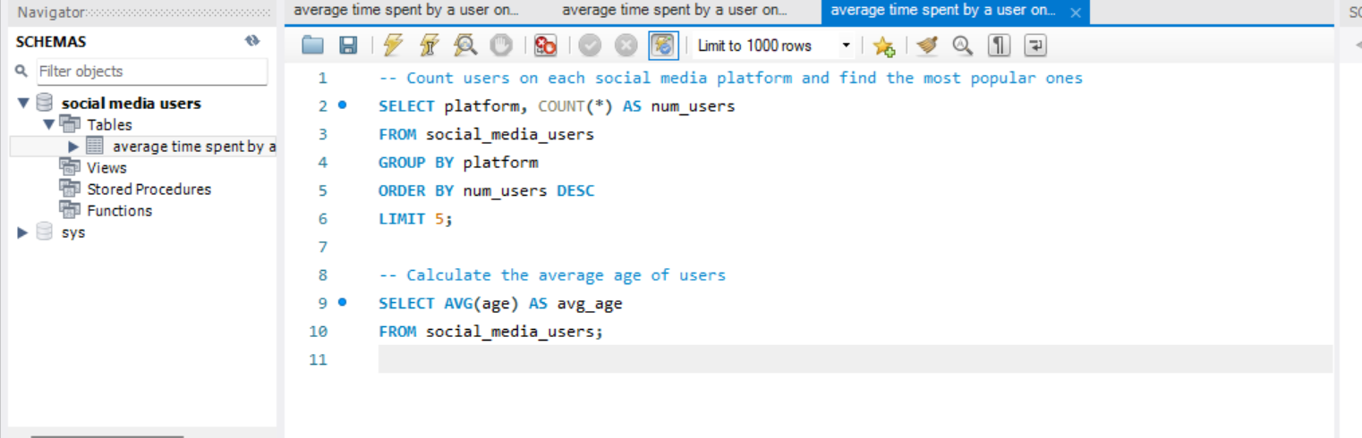

**3. Ask Away**

**Questions**:

1. **Which age group uses Instagram the most?**
2. **What is the gender distribution across different social media platforms?**

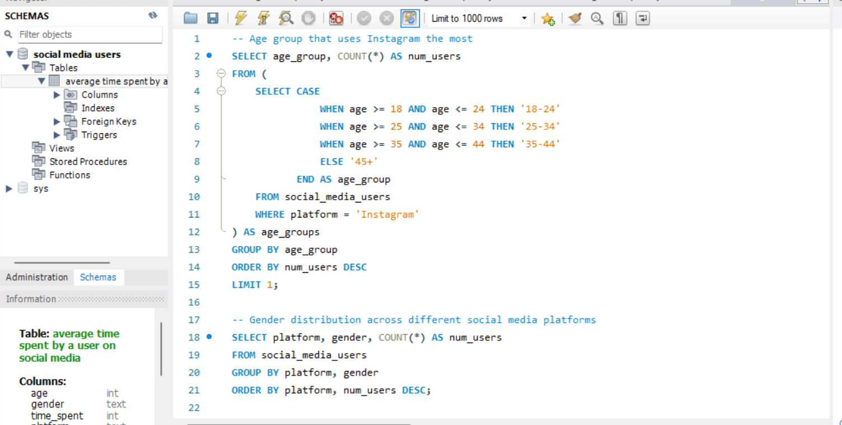

**Learnings**:

* From the answers, we might learn about the age demographics that are most engaged on Instagram.
* We could also understand the gender distribution differences across various social media platforms.

This structured approach allows us to effectively explore and analyze the Social Media Users dataset using SQL queries, uncovering insights and answering specific questions about the data. Adjustments can be made based on the actual dataset structure and specific SQL capabilities of the database used.